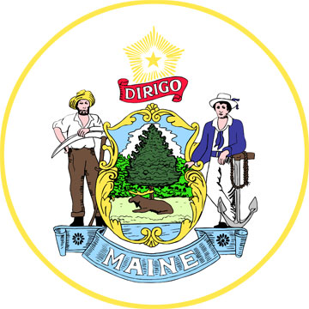 | SIM X Subcommittee  Date: 3/19/14  Time:10-12pm  Location: Bangor Public Library, Bangor, ME

Chair and Staff: Barbara Ginley, Jim Braddick

Member Attendance (A-Z): Linda Coleman, Marcia Cooper, Patty Hamilton, Theresa Mudgett, Jessica Fogg, Ben Hummell,

Ad Hoc Attendance:

Interested Parties:

Members Absent:

Subcommittee documents available at: (insert web address)

Agenda Item/Related SIM Objective (if applicable) | Obj. SST ID | Risk/concern discussed | Escalation to Steering (y/n)
 |  |  | N
 |  |  | N
Agenda Item |  | Discussion Points and Decisions
Announcements |  | 1. RFP released this morning. Bidders’ conference scheduled for April 1, 1:00 – 3:00 at MCD in Augusta Maine.  2. Upcoming Unity Conference http://www.usm.edu/health/csho-unity-conference to be held in May, one of the few convenings of CHWs nationally.  3. Launch of website supporting RFP materials, description of materials on this site. Info from Stakeholder Group members and others can be added. The CHWPP would like stories of CHW’s in Maine to add to this site – invitation to Stakeholder Group to contribute.
Review of Minutes from Previous Meeting |  | 1. Incorrect spelling of name noted and corrected.  2. No additional revisions.
Common Language for Roles and Responsibilities |  | 1. Review of Draft dated Monday, March 17. Barbara put this document together from the comments received at the last meeting, grouped by theme. Differentiation of clinical vs. non-clinical work. Can accommodate tiered responsibilities based on experience and/or level of experience. Serious need for role clarity for CHW’s vis a vis other members of health care team. Need to get buy-in at the outset for roles.  2. Review/discussion of CHW definitions from other states as incorporated into this document.  3. Question/concern about loss of public health focus if CHW’s are fully drawn into the culture of their organization. Varies according to location: states that have significant public health infrastructure have CHW’s working in traditional public health roles, and in other states they are more focused on individual patient care. Important for recipients of care to know where CHW’s fit.  4. Discussion of changes to wording in draft document.  5. Recognition of how location in state factors in to needs for and utilization of CHW.  6. Need to strike balance between the big picture and the specifics (i.e MN & MA)  7. Language and culture have been left out of our draft- include some of the language from MA.  6. Do CHW’s focus on “patients” or “people?”  7. Discussion/recommendations on format for document.
Meeting Evaluation |  | 1. Like size of room, good for conversation  2. Meeting process worked well for small size of group  3. Acknowledgement that calling in to a meeting doesn’t work well, desire to utilize video teleconferencing for better remote participation.
Public Comment

New Actions
Agenda Item | Action Items | Status | Who | Due By
Common Language for Roles and Responsibilities | Barbara to look for sample MA CHW job descriptions to accompany their definition. The work/ mark-ups from the Bangor and Portland meetings will be merged into one document to be shared with the full stakeholder group. |  | Barbara Ginley

Outstanding Actions
Reference |  | Action Items | Status | Who | Due By

